Setup 2

Specifications 2

Hardware Setup 2

Motor rotation direction 4

Solenoid power selection 5

Software Setup 6

Menu Selection 6

Production Run Settings 6

Adjust quantity 6

Adjust length 6

Reset production counts 7

Adjust motor speed menu 7

Adjust pierce distance 7

Adjust pierce quantity 8

Hardware Setup 8

Adjust pierce solenoid delay 8

Adjust cut solenoid delay 9

Adjust stepper motor counts per rotation 9

Adjust drive wheel diameter 10

Adjust solenoid offset 10

Programming with Arduino IDE 11

Programming the EEPROM 11

Programming the system program 14

# Setup

## Specifications

**Power supply:** 6 -> 14vdc, center positive

**Fuse:** 3A Max, 5x20mm glass fuse

**Solenoid:** 5v or Vin

**Stepper motor:** Vin, 5mm shaft, bipolar

## Hardware Setup

The system contains the follow external board connections;

* Five push-buttons
* Adjustable potentiometer
* Two E-stops, one active, one passive.
* 4-bit LCD
* Single pulse encoder
* Two solenoid relays, active low
* Stepper motor driver
* Fuse connector
* Power

The hardware parts list, PCB files and program, can be downloaded from the Git repository;

https://github.com/Heych88/Arduino-cutter

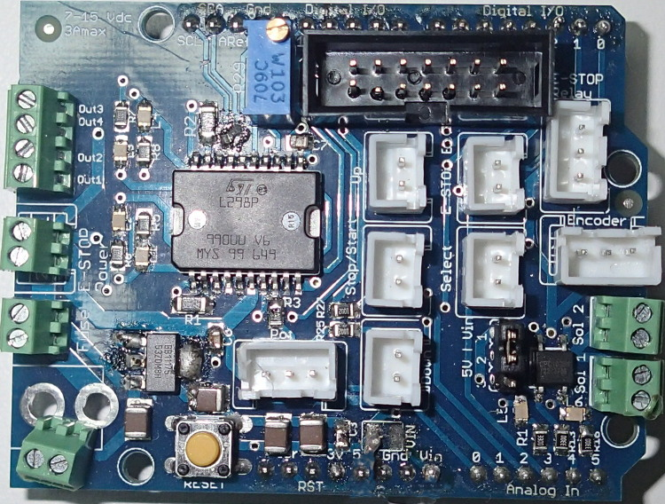

Stepper motor

E-stop return

E-stop Vin

Fuse return

Fuse Vin

Vin

Solenoid outputs

4-bit LCD

Solenoid voltage select

GND

Reset

E-stop sense

Up PB

E-stop active S + -



**S**

Select PB

Stop/Start PB

**S**

**S**

Encoder S + -

Pot - + S

Down PB

The wiring of the hardware, for most common operations, is as follows;

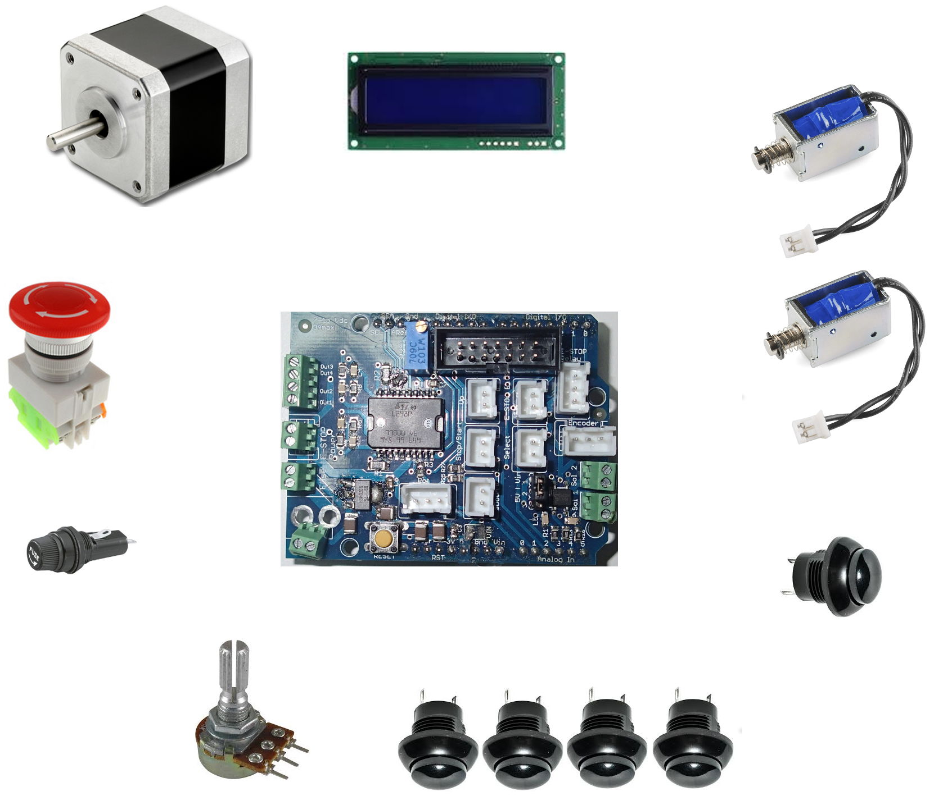

Alternate connection

Pierce

Cut

Up Down Stop/Stat Select

Vin GND

### Motor rotation direction

Upon installation of a stepper motor, the two winding pairs must be located. It is recommended to use a multimeter to measure the resistance between the wires. One winding pair must then be connected into the output connector group pairing of Out1 and Out2 and the second winding pair connected to Out3 and Out4.

Once connected, the motor will spin in a direction. If the motor is required to spin in the reverse direction, swap the group pairings with each other. I.e. Out1 swap with Out3, Out2 swap with Out4.

### Solenoid power selection

The solenoids can be supplied with either 5v or Vin. Both solenoids must power from the same supply and must both be either 5v or Vin.

The voltage can be changed by swapping the jumper on header JP1. See board for voltage configuration details.

For 5v solenoids, place the jumper on pins 1 and 2. For Vin solenoids, put the jumper on pins 2 and 3.

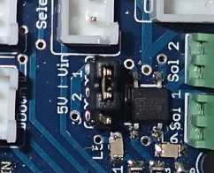

## Software Setup

### Menu Selection

The controller contains 11 adjustable menu selections. Six for adjusting production runs and five for system specific hardware setup.

To enter the system menu, press the up button.

To navigate the system menu, press either the up or down buttons.

To select a menu, press the SEL button, and a flashing cursor will appear on the screen.

### Production Run Settings

#### Adjust quantity

Adjusts the desired production quantity to be produced with the desired product specifications, as outlined in other sections.

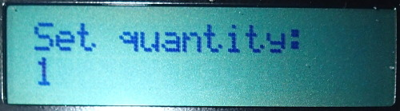

1. Navigate to the "Set quantity" menu using the **UP** or **DOWN** buttons.
2. Press the **SEL** button, and a flashing cursor will appear. If the flashing cursor doesn’t appear, press the **SEL** button until it does.
3. Adjust the desired quantity using the **UP** or **DOWN** buttons.
4. Press the **SEL** button to set the desired quantity and return to the home screen.

#### Adjust length

Adjusts the total desired product length.

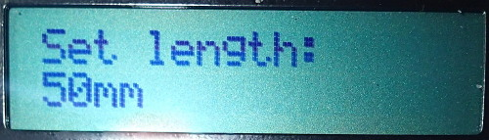

1. Navigate to the "Set length" menu using the **UP** or **DOWN** buttons.
2. Press the **SEL** button, and a flashing cursor will appear. If the flashing cursor doesn’t appear, press the **SEL** button until it does.
3. Adjust the desired length using the **UP** or **DOWN** buttons.
4. Press the **SEL** button to set the desired length and return to the home screen.

#### Reset production counts

Resets the number of the already produced product.

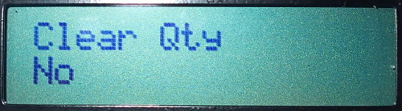

1. Navigate to the "Clear Qty" menu using the **UP** or **DOWN** buttons.
2. Press the **SEL** button, and a flashing cursor will appear. If the flashing cursor doesn’t appear, press the **SEL** button until it does.
3. Press the **UP** button until the display changes to "Yes".
4. Press the **SEL** button to rest the produced quantity and return to the home screen.

#### Adjust motor speed menu

Adjusts the motors running speed. This menu is only used for display purposes only.

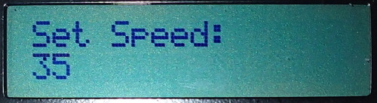

1. Navigate to the "Set Speed" menu using the **UP** or **DOWN** buttons.
2. Adjust the speed using the SPEED DIAL until at the desired speed.
3. Navigate to the home menu with the **DOWN** button.

#### Adjust pierce distance

Adjusts the distance from the end of the desired length to add a pierce.

If the number of pierces is two, a pierce is performed at the desired distance from the start of piece and the desired distance from the final length of the part.

If the number of pierces is one, a pierce is only performed at the desired distance from the start of piece.

The pierce distance is calculated from the product edges and the centre of the piercing die.

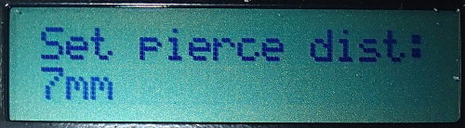

1. Navigate to the "Set pierce dist" menu using the **UP** or **DOWN** buttons.
2. Press the **SEL** button, and a flashing cursor will appear. If the flashing cursor doesn’t appear, press the **SEL** button until it does.
3. Adjust the desired length using the **UP** or **DOWN** buttons.
4. Press the **SEL** button to set the desired distance and return to the home screen.

#### Adjust pierce quantity

Resets the number of piercings in each product piece.

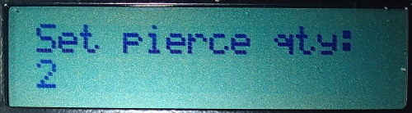

1. Navigate to the "Set pierce qty" menu using the **UP** or **DOWN** buttons.
2. Press the **SEL** button, and a flashing cursor will appear. If the flashing cursor doesn’t appear, press the **SEL** button until it does.
3. Adjust the desired quantity using the **UP** or **DOWN** buttons.
4. Press the **SEL** button to set the quantity and return to the home screen.

### Hardware Setup

#### Adjust pierce solenoid delay

Adjusts the time delay for activating and deactivating the solenoid used for piercing in milliseconds.

The total solenoid time is double the delay time set, as the delay time set is the full time that the solenoid is activated (set Low) and the identical time to release and retract the solenoid (set High) back to its deactivated state.

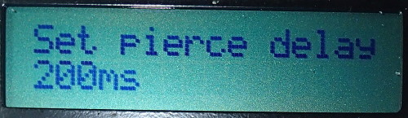

1. Navigate to the "Set pierce delay" menu using the **UP** or **DOWN** buttons.
2. Press the **SEL** button, and a flashing cursor will appear. If the flashing cursor doesn’t appear, press the **SEL** button until it does.
3. Adjust the desired delay using the **UP** or **DOWN** buttons.
4. Press the **SEL** button to set the required delay time and return to the home screen.

#### Adjust cut solenoid delay

Adjusts the time delay for activating and deactivating the solenoid used for cutting in milliseconds.

The total solenoid time is double the delay time set, as the delay time set is the entire time that the solenoid is activated (set Low) and the identical time to release and retract the solenoid (set High) back to its deactivated state.

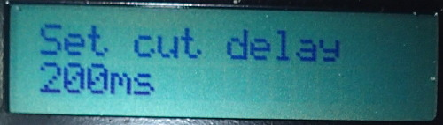

1. Navigate to the "Set cut delay" menu using the **UP** or **DOWN** buttons.
2. Press the **SEL** button, and a flashing cursor will appear. If the flashing cursor doesn’t appear, press the **SEL** button until it does.
3. Adjust the desired delay using the **UP** or **DOWN** buttons.
4. Press the **SEL** button to set the required delay time and return to the home screen.

#### Adjust stepper motor counts per rotation

Changes the number of steps for one full stepper motor revolution.

This is specific to each motor. Check the datasheet of the motor for more information.

If a geared system is used, the gear ratio must be factored into consideration here. I.e. a motor step count of 200 with a motor to wheel gear ration of 10:1, set the step count to 2000.

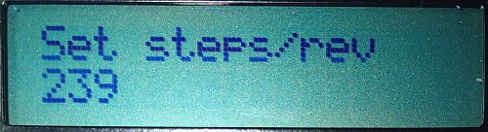

1. Navigate to the "Set steps/rev" menu using the **UP** or **DOWN** buttons.
2. Press the **SEL** button, and a flashing cursor will appear. If the flashing cursor doesn’t appear, press the **SEL** button until it does.
3. Adjust the steps using the **UP** or **DOWN** buttons.
4. Press the **SEL** button to set the required steps and return to the home screen.

#### Adjust drive wheel diameter

Adjusts the diameter of the drive wheel that is driven by the drive motor.

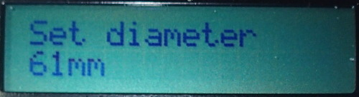

1. Navigate to the "Set diameter" menu using the **UP** or **DOWN** buttons.
2. Press the **SEL** button, and a flashing cursor will appear. If the flashing cursor doesn’t appear, press the **SEL** button until it does.
3. Adjust the diameter using the **UP** or **DOWN** buttons.
4. Press the **SEL** button to set the diameter and return to the home screen.

#### Adjust solenoid offset

Adjusts the distance between the pierce and cut solenoids in mm.

The pierce solenoid is MUST be placed before the cutting solenoid, in the direction of travel.

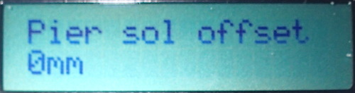

1. Navigate to the "Pier sol offset" menu using the **UP** or **DOWN** buttons.
2. Press the **SEL** button, and a flashing cursor will appear. If the flashing cursor doesn’t appear, press the **SEL** button until it does.
3. Adjust the offset distance between the cutting blade and the centre of the piercing die using the **UP** or **DOWN** buttons.
4. Press the **SEL** button to set the required steps and return to the home screen.

# Programming with Arduino IDE

The brains behind the program is an Arduino Leonard.

A new Leonardo can be programmed using the Arduino IDE which can be downloaded for free from the Arduino site;

<https://www.arduino.cc/en/Main/Software>

Install the software as required by your operating system. I.e. For windows download and run the .exe file.

## Programming the EEPROM

If you are installing a brand-new Arduino Leonardo board, the EEPROM must be flashed first. If it is the existing system board, this step can be skipped.

The code can be downloaded from the Git repository;

https://github.com/Heych88/Arduino-cutter

1. Run the Arduino IDE
2. Click File > Open

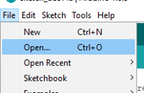

1. Navigate to the programs code location and select the eeprom_write.ino file by navigating to *<Saved path>/src/eeprom_write/eeprom_write.ino*

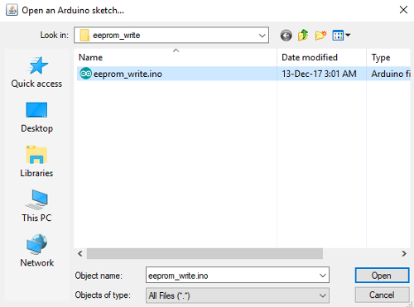

1. Click open
2. Set the board type under Tools > Board, select Arduino Leonardo.

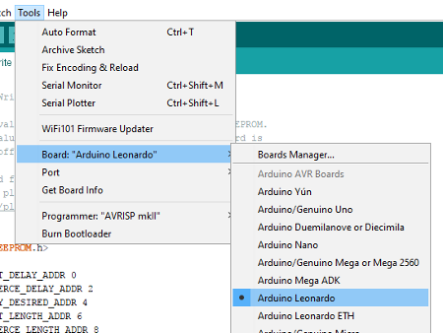

1. Connect the Arduino board to the computer using the micro USB port. It is recommended to remove all other external power supplies before and during USB connection to the PC.
2. Assign the correct computer port that the Arduino is connected too, under Tools > Port > COMx (Arduino Leonard).

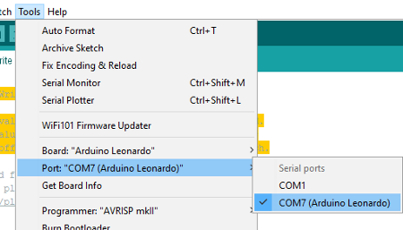

Note: The COM port used above may vary between machines.

1. On the main screen, click the Verify icon, tick icon. This will compile the program.



1. If no errors have occurred, click on the Upload icon, arrow icon.



1. Once uploaded the program will run automatically, and when complete, the program will turn on Pin 13 LED.
2. If Pin13 LED, onboard LED ‘L ‘, is on. You have successfully loaded the EEPROM onto the device. You can now move onto the main program load sequence.

## Programming the system program

If you are installing a brand-new Arduino Leonardo board, the EEPROM must be flashed first. See above for details.

The code can be downloaded from the Git repository;

https://github.com/Heych88/Arduino-cutter

1. Run the Arduino IDE
2. Click File > Open



1. Navigate to the programs code location and select any .ino file by navigating to *<Saved path>/src/xxx.ino*

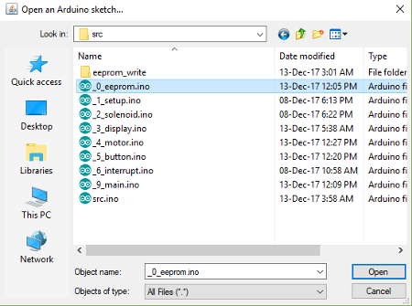

1. Click open
2. Set the board type under Tools > Board, select Arduino Leonardo.



1. Connect the Arduino board to the computer using the micro USB port. It is recommended to remove all other external power supplies before and during USB connection to the PC.
2. Assign the correct computer port that the Arduino is connected too, under Tools > Port > COMx (Arduino Leonard).



Note: The COM port used above may vary between machines.

1. On the main screen, click the Verify icon, tick icon. This will compile the program.



1. If no errors have occurred, click on the Upload icon, arrow icon.



1. Once uploaded, the board can be unplugged from the PC, and the system power can be plugged in again. Upon powerup, the system will operate as usual.